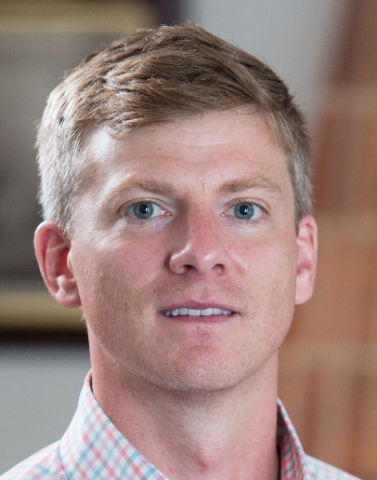
Reid Groseclose is a Director and GSK Fellow of Bioimaging at GSK. He earned his B.S. in chemistry from the University of Tennessee in 2004 and his Ph.D. in chemistry from Vanderbilt University in 2009 in the lab of Richard Caprioli, where his work focused on exploring the utility of imaging mass spectrometry and on-tissue proteomics for the analysis and classification of cancerous tissues. He joined GSK in 2009, where his research interests have centered on the application of imaging mass spectrometry to assess the tissue distribution of drugs and their metabolites. His group is particularly interested in using IMS to quantify the localized tissue concentration of drug candidates and investigating mechanisms of pharmacology and safety.

